P615/1
Art and Craft
Paper 1
2 ½ hours

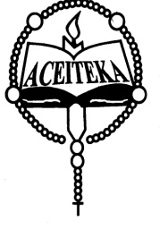
ACEITEKA JOINT MOCK EXAMINATIONS 2023
UGANDA ADVANCED CERTIFICATE OF EDUCATION
ART AND CRAFT
PAPER 1
DRAWING OR PAINTING FROM STILL LIFE/NATURE STUDY
TIME: 2 HOURS 30 MINUTES

Instructions:
- Attempt one question out of the alternatives
- On the top right corner of the final work measure 5cm x 12cm that space should not be painted and in it write your name, class stream, Index number if you have one.
- The use of rulers or any other mechanical means is not allowed.

ALTERNATIVE A (STILL LIFE)
Either

- On a floor towards the left placed is a locally woven laundry basket inside which a plain fabric is inserted. The fabric is made to drape from the basket to the floor with good curls diagonally towards the right. On the right but at the back placed is a jerrycan with its spout facing the left, and in front of it is a basin half filled with water. On the right hand of the basin place a big packed of Nomi powder detergent in 3¼ view and in between the packet and the basin but in front place a bar of soap lying on the floor towards the candidates. Candidates draw the whole composition.

OR
NATURE STUDY

- Make a study or studies of a mature uprooted yam plant with leaves intact and some tuber developed

OR

- Make a study or studies of a wasp.

OR

- Candidates draw a landscape around the school environment, in which they should include two buildings, a banana plantation and some trees in the back ground, and a foot path.

END

